*rentall*

specifications

Contents

OVERVIEW 1

PROJECT TEAM 1

GOALS 1

FUNCTIONALITY 2

*USER STORIES* 2

*APPLICATION MENU* 3

# OVERVIEW

*RentAll web application is needed for the administration of the lease agreements within a chain of shopping centers, that will generate an increased revenue and a better management of the leases and tenants’ relationship.*

# PROJECT TEAM

Raluca Rosu – raluca.rosu@amdaris.com

Mentor: Dan Patrascu

# GOALS

* Increase revenues by 10%
* Reduce breaches of lease terms by 25%

# FUNCTIONALITY

*RentAll will be used by the:*

* *leasing department for managing the lease agreements;*
* *shopping center manager for supervising leasing department’s activity, incomes and occupancy degree reports related to the SC.*

### *USER STORIES*

User Registration

In order to have access to the web application, you need to create a user (user name + password).

There will be three types of users: **leasing manager, shopping center manager, admin**.

Each type of user will have a different role, with different rights.

Admin:

* gives roles to the users;
* creates/edits/deletes SC and all the premises within the SC.

Leasing Department:

* adds new company with contact persons;
* creates/edits/views lease agreements;
* generates leasing reports.

SC manager:

* approves the lease agreements sent for approval by the leasing department;
* views lease agreements;
* generates leasing reports.

### *APPLICATION MENU*

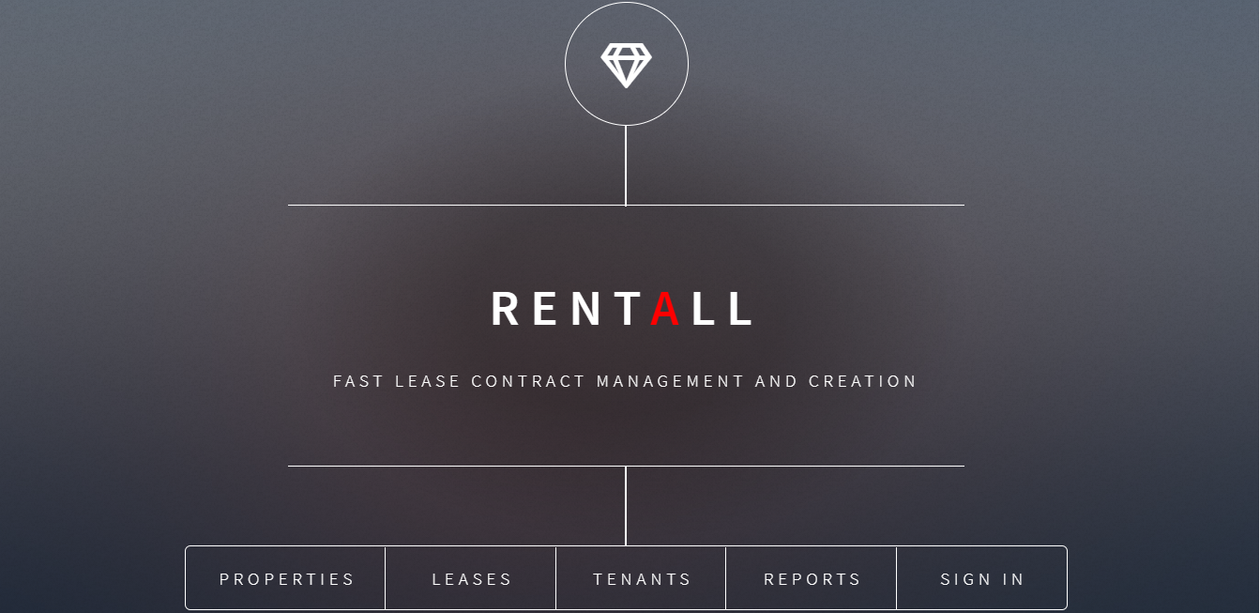

|  |  |  |  |
| --- | --- | --- | --- |
| **Properties** | **Leases** | **Tenants** | **Reports** |
| View center details:   * Owner * Address * Gross Leasable Area (GLA) * Opening Date * Parking lots | View list of leases/SC:   * Unit code * Area * Tenant * Rent/sqm * CAM/sqm * Marketing/sqm * Signing date * Start date * Term * Cease date * View->Edit link | View list of tenants:   * Company name; * Address; * Contact persons; * View->Edit link * Link to a list of contracts | On each center:   * Monthly incomes; * Average rent; * Leases that expire within x months; * Occupancy degree vs vacant units |
| View list of premises:   * Unit code * Area * Link to current lease | Add new lease:   * Center * Premises * Tenant * Rent/sqm * CAM/sqm * Marketing/sqm * Signing date * Start date * Term * Leasing Manager | Add new tenant:   * Company name; * CUI; * Fiscal attribute; * RECOM no.; * Address; * Contact persons; | Comparisons on all centers |
|  |  |  |  |